911 Address Request Form
Please Return to
407 Main Street South, Room 307
Towner, ND 58788
Or
Email to
Pierceem@nd.gov

Date ________________________

Owner or Resident:

Name: __________________________________________________________________________________
Current Mailing Address: ________________________________________________________________________
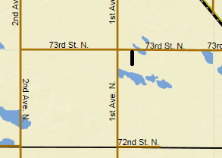
City _________________ State________________ Zip Code________________
Telephone Number____________________________________________________
Building Location: (Please include a sketch if possible)
Township Name, Section and Quarter : ____________________________________
Parcel ID: ____________________________________
Road that permanent driveway will branch off of___________________________(ex:73rd ST N)
Avenue or Street that driveway will be parallel with_________________________________ (ex: 1st Ave N)
Distance and direction from parallel road to driveway__________________________________(ex: 300ft East of 1st Ave N)
Closest Neighbor_____________________________________________
Closest Neighbor’s Address____________________________________________
Are there any current structures on the property? yes no
If yes, What are the structure(s)?________________________________________________________
If no, what will be built? ________________________________________________________________
When will it be built?___________________________________________________________________
___________________________________Official Use Only____________________________________
New Address Assigned_______________________________________________________
Date of Notification___________________

